- Data Design

The proposed Mechanical Workshop Inventory Systems has a database which includes eight (8) tables wherein all the actions and transactions of the cashier is recorded. These tables are the Contacts table, Employee Login table, Employee Security table, Products table, Sales table, Transactions table, Cashier Login table, and the Cashier Security table.
- Contacts Table – a table in the system database where the added contacts are saved. This table contains six (6) fields namely, Contact ID, Name, Address, Phone No., Cellphone No., and Email which all contain information about a certain contact person.
- Employee Login Table – a table which saves the login record to the system of an employee. This table contains six (6) fields namely, Login No, Employee ID, Employee Name, Login Time, Log out, and Date which all contain information about the log in of an employee.
- Employee Security Table – a table which saves the security information of an employee. This table contains five (5) fields namely, Employee No., Employee Name, Employee Full Name, Position, and Password.
- Products Table – a table which records all the available products in the inventory. This table contains seven (7) fields namely, Product ID, Product Name, Unit Price, Stocks, Total Price, Description, and Date which all contain information about the available products.
- Sales Table – a table which records all the sales that the Shop has gotten. This table contains six (6) fields namely, Product ID, Product Name, Stocks Purchased, Subtotal, Date, and Cashier Name which all contain information about the sold products and the Employee present during the Sales.
- Transactions Table – a table which records all the transactions related to the sales of particular products. This table contains seven (7) fields namely Transaction No., Login No., Cashier Name, Date, Total Amount, Cash, and Change.
- Cashier Login Table – a table which saves the login record to the system of a customer. This table contains six (6) fields namely Login No, Cashier ID, Cashier Name, Login Time, Logout, and Date which all contain information about the log in of a cashier.
- Cashier Security Table - a table which saves the security information of a cashier. This table contains five (5) fields namely Cashier ID, Cashier Name, Cashier Full Name, Cashier Position, and Password.

B.) Architectural Design
The objective of an Architectural Design is to develop a modular program structure and represent the control relationships between modules.

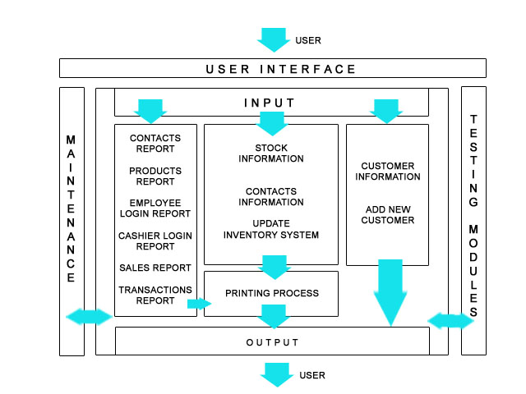
Architectural Design of MECHANICAL WORKSHOP
INVENTORY SYSTEM

C.) Interface Design

This system is composed of one main form for the employee with a tab menu composed of four submenus and a main form for the cashier.
1.) Select Login Form
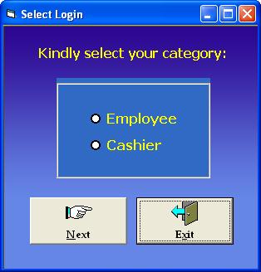
Figure 2

Before accessing the system, the user is given the choice to log in either as an Employee or a Cashier as shown in Figure 2.

2.) Employee Login Form
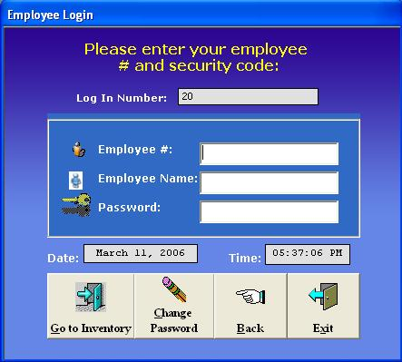
Figure 3

If he/she chooses to enter the system as an Employee, he/she is asked to enter his/her Employee Number, Name and Password as shown in Figure 3.

3.) Change Employee Password Form
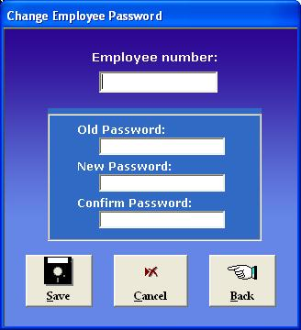
Figure 4

The employee can also change his/her old password by going to the Change Employee Password form as shown in Figure 4. He/she is asked to enter his/her Employee Number, Old Password, a New Password and a confirmation of the New Password.
After logging in as an Employee, the user will be directed to the Main Inventory System of the employee, where the user can choose to do an activity from the four sub menus. The four submenus are the General Menu, Contacts Menu, Products Menu, and Reports Menu.

4.) Employee Main Inventory - General
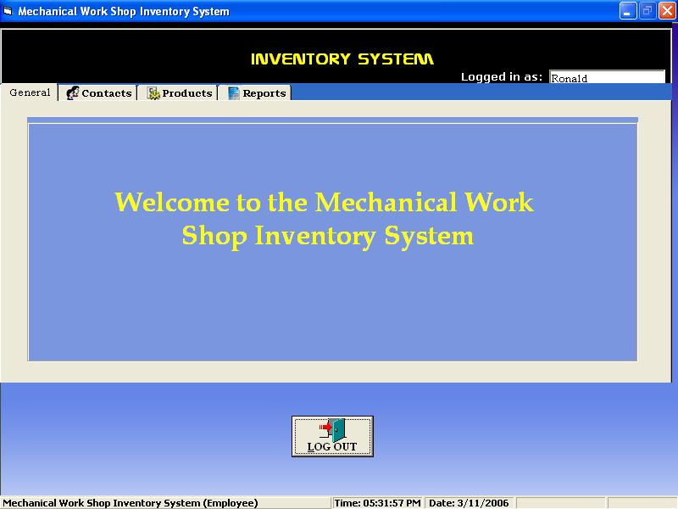
Figure 5

In the General Menu, a display is shown welcoming the user to the system as shown in Figure 5.

5.) Employee Main Inventory - Contacts
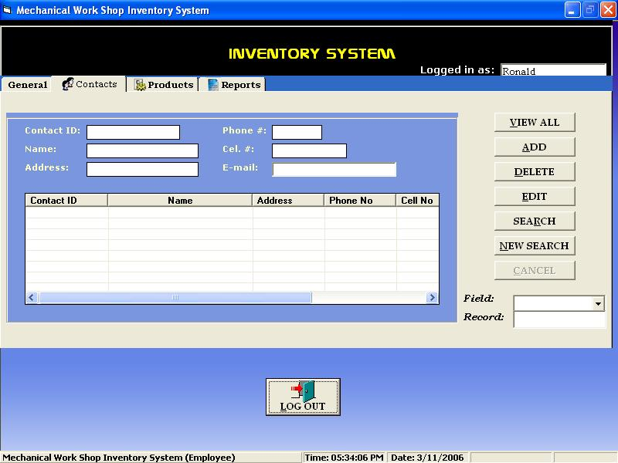
Figure 6

In the Contacts Menu contains seven (7) submenus namely, View All, Add, Delete, Edit, Search, New Search, and Cancel as shown in Figure 6.
- View All – allows the user to view all the saved records or contacts in the database of the system.
- Add – allows the user to add a new record or contact in the database of the system.
- Delete – allows the user to delete a record or contact in the database of the system.
- Edit – allows the user to edit an existing record or contact in the database of the system.
- Search – allows the user to enter a data in the Field type and Record for the data to be searched through the saved records in the database of the system.
- New Search – clears all fields for the user to be able to do a new search in the database of the system.
- Cancel – to cancel the current transaction being done by the user.
6.) Employee Main Inventory - Products
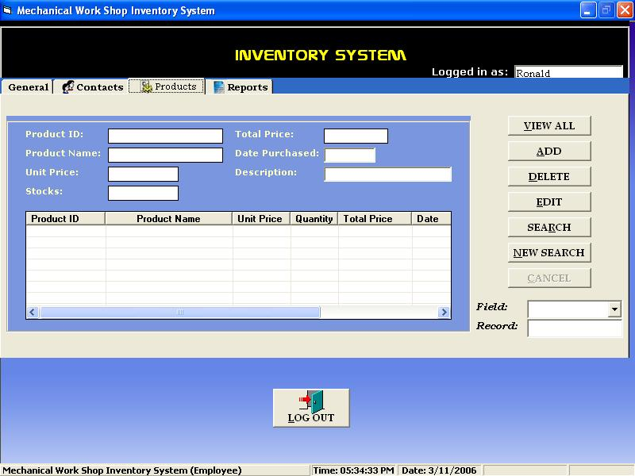
Figure 7

In the Products Menu, the same submenus that are in the Contacts Menu are present as shown in Figure 7. These submenus are View All, Add, Delete, Edit, Search, New Search, and Cancel. All submenus serve the same purpose as the menus in the Contacts Menu.

7.) Employee Main Inventory - Reports
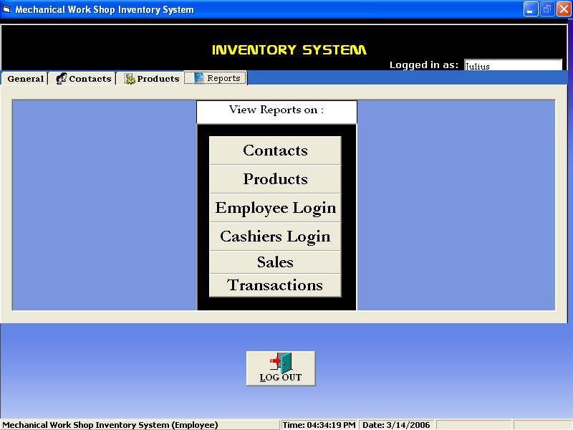
Figure 8

In the Reports Menu, the user is given the choice to view reports on Contacts, Products, Employee Login, Cashiers Login, Sales, and Transactions as shown in Figure 8.

8.) Cashier Login
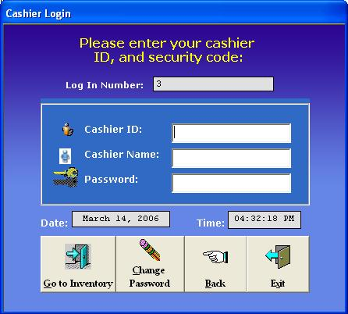
Figure 9

If the user chooses to enter the system as a Cashier, he/she is asked to enter his/her Cashier ID, Cashier Name and Password as shown in Figure 9.

9.) Change Cashier Password
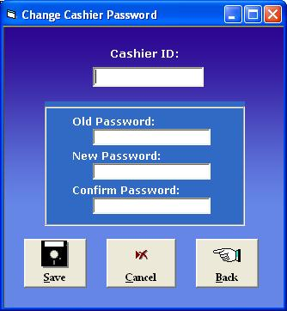
Figure 10

Just like in the Employee Login, the cashier may also change his/her old password by going to the Change Cashier Password form as shown in Figure 10. He/she is asked to enter his/her Cashier ID, Old Password, a New Password and a confirmation of the New Password.

10.) Cashier Main Inventory
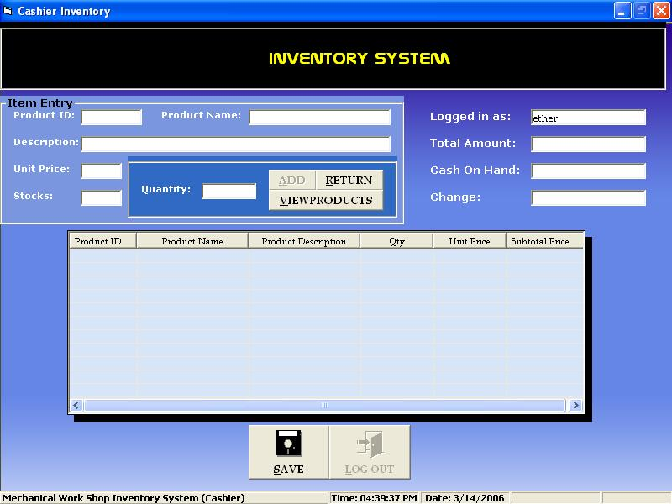
Figure 11

After the cashier has successfully login, he/she will be directed to the Main Inventory System of the Cashier where he/she can make transactions as shown in Figure 11. It contains ten (10) fields. These fields are the Product ID, Product Name, Description, Unit Price, Stocks, Quantity, Logged in as, Total Amount, Cash on Hand, and Change.
- Product ID – a field where the cashier is to input the product number of a certain item that a customer orders to be able to view information about that item. After entering a product number or Product ID, the Product Name, Description, Unit Price, and Stocks of that item will automatically be displayed in their respective fields.
- Product Name – displays the saved product name of an item in the system’s database.
- Description – displays a description of an item in the inventory.
- Unit Price – displays the unit price of an item in the inventory.
- Stocks – displays how many stocks in the inventory are still available for order.
- Quantity – this is where the cashier enters the amount or number of stocks that a customer wants to order in the inventory.
- Logged in as – this field displays the name of the employee logged in the system during a particular transaction.
- Total Amount – an amount automatically appears in this field after the cashier chooses a product in the inventory and enters the quantity of products that a certain customer wants to order. This is the total amount of the cash that a customer must pay to the cashier.
- Cash on Hand – this is the field where the cashier will input the amount of cash that he/she has on hand for the payment of the stocks that the customer has ordered.
- Change – this field displays the change that the user shall get after the transaction.
After the cashier is finished with his/her transactions, he/she should click the Save button to be able for the transaction to be saved in the database of the system.

D.) Component Level Design

This system was constructed with the use of the programming language – Microsoft Visual Basic 6.0 – for this language had the entire component that the system designers and programmers needed to create their system in mind which was the Mechanical Workshop Inventory System. A feature of the system is that it has its own database for the storage of information about its products, contacts, a login file for cashiers and employees, sales, and transactions. This was done through the use of the ADODC command in the programming language used that enabled the system to connect to a database made in MS Access.

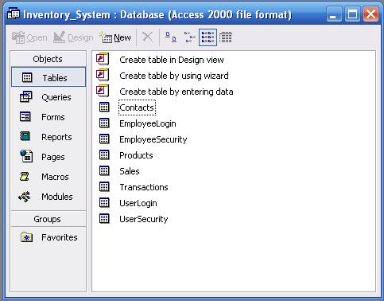
Screenshot of the Inventory System’s Database

